**MCCF EDI TAS eRevenue Resource   
SharePoint 2010 to 2013 Upgrade**

System Design Document



Department of Veterans Affairs

**July 2017**

Version 1.3

Table of Contents

1 Introduction 5

1.1 Purpose 5

1.2 Scope 5

1.3 Glossary 5

2 Requirements Traceability 6

3 Design Overview 7

3.1 Architecture Design 7

3.1.1 eRevenue Resource Home Page 7

3.1.2 Non MCCF Coordinator Page 9

3.1.3 Insurance Intake Page 12

3.1.4 Insurance Verification Page 15

3.1.5 Utilization Review Page 18

3.1.6 Billing 22

3.1.7 Pharmacy Page 27

3.1.8 OPECC Page 30

3.1.9 Accounts Receivable Page 33

3.1.10 NPI Program Page 36

3.1.11 Non-MCCF Program Page 38

3.1.12 Contact Information Window/Page 40

4. How to Update Content 43

4.1 SharePoint Objects 43

4.1.1 CBODocuments 43

4.3 SectionApps 44

4.1.5 eRevenue Page Layout 44

4.1.6 eRevenuePage and eRevenuePage2 Columns 45

4.1.7 eRevenuePage list 45

4.1.8 Add new eRevenue Page 45

4.1.9 Add a New Accordion 46

4.2.10 How to Upload a Document to Forms and Letters 47

4.2.1 How to Hide a Link in the Accordion 50

4.2.2 How to Delete an Accordion 51

4.2.3 How to Upload Images and Hyperlinks to CBO Documents 54

4.2.4 How to Upload Hyperlinks to CBO Documents 56

How to Create a HELP Link 57

5.0 Nintex Workflow 59

5.1 How to Archive a Document 60

5.2 How Move Documents Back to CBO Documents 61

5.3 Using Dataview to Move Documents 63

6.0 Term Store orKeywords 64

6.1 Use an Existing Term 64

7.0 Contact Email Form 66

7.1 Business Requirements 66

7.2 Select a Topic Dropdown 68

7.3 Select Station Dropdown 69

7.4 Sending the Email 70

**Revision History**

NOTE: The revision history cycle begins once changes or enhancements are requested after the document has been baselined.

| **Date** | **Revision** | **Description** | **Author** |
| --- | --- | --- | --- |
| July 2017 | 1.3 | Remove task/to do under Section 7.4 | Alex Garnica |
| July 2017 | 1.2 | Updated “TBD” sections with content information | Jeff Kuwic |
| July 2017 | 1.1 | User stories added after the initial version are added to this release. Additional How To sections added. | MCCF EDI eAdmin |
| March 2017 | 1.0 | Initial Version | MCCF EDI eAdmin |

# 1 Introduction

# Purpose

This Software Design Document provides the design details using eRevenue Resource SharePoint site as defined in US266—SharePoint 2010 to SharePoint 2013 Upgrade (Defect Remediation).

The target audience is VA PMs, eBusiness Product Owners, Developers and PMO team members. It will also serve as a reference for those who will maintain the production system.

# Scope

This document contains a complete description of the design of the new eRevenue Resource SharePoint site. The basic architecture is the VA SharePoint 2013 implementation. The basic pages will use SharePoint Designer with scripting in HTML and JavaScript.

# Glossary

|  |  |
| --- | --- |
| Term | Definition |
| HTML | Hyper Text Markup Language |
| LOV | List of Values |
| SDD | System Design Document |

# Requirements Traceability

To confirm requirement traceability the following list denotes approved User Stories. These User Stories (identified by their Rally ID) are tied to the each of the artifacts described in Section 3: Design Overview.

* US241 – Site Performance
* US243 – Back Button Functionality
* US244 – Hover Text Disappearing
* US248 – Search Icon Missing Next to Search Bar on eBusiness Solutions Home Page, Project and Profile Pages
* US249 – Update to Overall Search Functionality
* US253 – Search - Displaying Multiple Icons
* US254 – Calendar-News You Need to Know Announcement Background
* US255 – Calendar - Foreign Object Display
* US256 – Unable to Open Documents or Links (Multiple Pages)
* US257 – Duplicate Document Display
* US259 – Site Generate Emails
* US261 – Document Prioritization Order
* US262 – Unable to View Newly Created Announcements
* US264 – Calendar-News You Need to Know- Shrinking Pages
* US270 – Migration from SharePoint 2010 to SharePoint 2013 (EO) - Beta Site
* US271 – Validate Site is 508 Compliant - Features/Changes Post Migration
* US275 – Complete Development in PROD
* US1385 – Blank IE Tab - Selecting Documents/Links
* US1386 – Spell Check
* US1387 – NPI Project Page
* US1392 – Global View More Feature
* US1681 – Develop Master Page – Sprint 1
* US1710 – UI Usability and Consistency Changes
* US1758 – Master Page Development – Sprint 2
* US1765 – Nintex Workflow

The following Technical User Stories are also included in this release.

* US1682 – Regression Testing
* US1894 – File Management / BitBucket
* US272 – Validate Migration / Begin Development in Beta Environment (Office 365)
* US276 – Complete E2E Testing

# Design Overview

# 3.1 Architecture Design

### 3.1.1 eRevenue Resource Home Page

**Name:** eRevenue Resource Home Page

**Type:** Web Page

**Description:** Figure 1 presents the initial landing page for end users (consumers) when they connect to the eRevenue Resource SharePoint site. The page contains the following elements:

* Header
* VA Logo
* Page Title
* Search Bar
* Breadcrumb
* Current Date/Time
* Navigation Bar
* Home Page Icon
* Non MCCF Coordinator
* Insurance Intake
* Insurance Verification
* Utilization Review
* Billing
* Pharmacy
* Outpatient Pharmacy Electronic Claims Coordinators (OPECC)
* Accounts Receivable
* **Web Parts (Accordions)**
* EDI Software Development Updates
* Industry Insights
* Contact Information
* Calendar
* Quick Links
* eInsurance
* eBilling
* ePayments
* ePharmacy
* **Footer**
* Office of Community Care (OCC) Link
* Consolidated Patient Account Centers (CPAC) Link
* National Service Desk Link
* VA Pulse Link
* NPI Program Link
* Non-MCCF Program Link
* Star Logo Graphic
* Operations
* Pre-condition: Connected to site
* Post-condition: On another page
* Exceptions: None
* Event Flow

1. End user is presented with the eRevenue Resource Home Page
2. End user selects link/button
3. End user is connected to another page

**Additional SharePoint Configuration:**

* Configure Managed Metadata term set to apply global navigation in the horizontal navigation bar.

**Additional Technical Details:**

* Complete HTML,master page, CSS and JavaScript custom code.

**Requirements Traceability:**

* US241 – Site Performance
* US243 – Back Button Functionality
* US244 – Hover Text Disappearing
* US248 – Search Icon Missing Next to Search Bar on eBusiness Solutions Home Page, Project and Profile Pages
* US249 – Update to Overall Search Functionality
* US253 – Search - Displaying Multiple Icons
* US254 – Calendar-News You Need to Know Announcement Background
* US255 – Calendar - Foreign Object Display
* US256 – Unable to Open Documents or Links (Multiple Pages)
* US257 – Duplicate Document Display
* US259 – Site Generate Emails
* US261 – Document Prioritization Order
* US262 – Unable to View Newly Created Announcements
* US264 – Calendar-News You Need to Know- Shrinking Pages
* US270 – Migration from SharePoint 2010 to SharePoint 2013 (EO) - Beta Site
* US271 – Validate Site is 508 Compliant - Features/Changes Post Migration
* US275 – Complete Development in PROD
* US1385 – Blank IE Tab - Selecting Documents/Links
* US1386 – Spell Check
* US1387 – NPI Project Page
* US1392 – Global View More Feature
* US1681 – Develop Master Page – Sprint 1
* US1710 – UI Usability and Consistency Changes
* US1758 – Master Page Development – Sprint 2

Figure : Wireframe

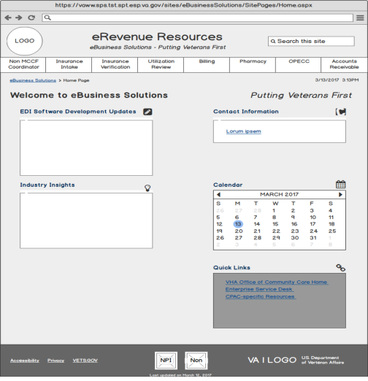

### 3.1.2 Non MCCF Coordinator Page

**Name:** Non MCCF Coordinator Page

**Type:** Web Page

**Description:** Clicking the **Non MCCF Coordinator** link from the **eRevenue Resource Home Page**, will display the Non **MCCF Coordinator Page** (shown in Figure 2). This page will have a combination of web parts and links as shown in the following list:

* **Header**
* VA Logo
* Page Title
* Search Bar
* Breadcrumb
* Current Date/Time
* Navigation Bar
* Home Page Icon
* Non MCCF Coordinator
* Insurance Intake
* Insurance Verification
* Utilization Review
* Billing
* Pharmacy
* OPECC
* Accounts Receivable
* Web Parts (Accordions)
* New Non-MCCF Coordinator Information
* Forms and Letters – Non-MCCF
* Contact Information – Non-MCCF
* Regulations and Directives
* User Guides and Documentation – Non-MCCF
* Training Presentations
* Help – Non-MCCF Coordinator
* Non MCCF Coordinator POC
* Footer
* Office of Community Care (OCC) Link
* Consolidated Patient Account Centers (CPAC) Link
* National Service Desk Link
* VA Pulse Link
* NPI Program Link
* Non-MCCF Program Link
* Star Logo Graphic
* Operations
* Pre-condition: Connected to site
* Post-condition: Document/Links accessed or connect to another page
* Exceptions: None
* Flow of Events

1. End user is presented with the Non MCCF Coordinator Page
2. End user selects link and is taken to another page
3. End user selects a document is the document is open

**Additional SharePoint Configuration:**

* Add a new SharePoint page (.aspx) to the site.

**Additional Technical Details:**

* Content for MCCF page needs to be applied – accordion controls, calendars, etc.

**Requirements Traceability:**

* US241 – Site Performance
* US243 – Back Button Functionality
* US244 – Hover Text Disappearing
* US248 – Search Icon Missing Next to Search Bar on eBusiness Solutions Home Page, Project and Profile Pages
* US249 – Update to Overall Search Functionality
* US253 – Search - Displaying Multiple Icons
* US254 – Calendar-News You Need to Know Announcement Background
* US256 – Unable to Open Documents or Links (Multiple Pages)
* US257 – Duplicate Document Display
* US259 – Site Generate Emails
* US261 – Document Prioritization Order
* US262 – Unable to View Newly Created Announcements
* US264 – Calendar-News You Need to Know- Shrinking Pages
* US270 – Migration from SharePoint 2010 to SharePoint 2013 (EO) - Beta Site
* US271 – Validate Site is 508 Compliant - Features/Changes Post Migration
* US275 – Complete Development in PROD
* US1385 – Blank IE Tab - Selecting Documents/Links
* US1386 – Spell Check
* US1387 – NPI Project Page
* US1392 – Global View More Feature
* US1681 – Develop Master Page – Sprint 1
* US1710 – UI Usability and Consistency Changes
* US1758 – Master Page Development – Sprint 2

Figure : Wireframe

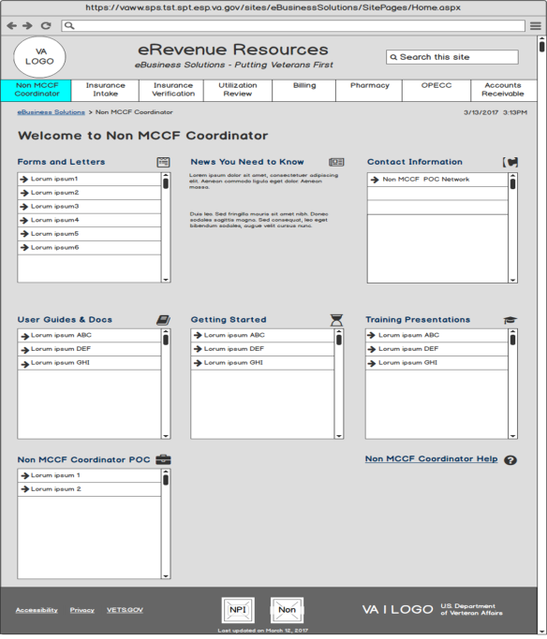

## 3.1.3 Insurance Intake Page

**Name:** Insurance Intake Page

**Type:** Web Page

**Description:** Clicking the the **Insurance Intake** link from the **eRevenue Resource Home Page**will display the Insurance Intake page (shown in Figure 3). This page will have a combination of web parts and links. This page will have a combination of web parts and links as shown in the following list:

* Header
* VA Logo
* Page Title
* Search Bar
* Breadcrumb
* Current Date/Time
* Navigation Bar
* Home Page Icon
* Non MCCF Coordinator
* Insurance Intake
* Insurance Verification
* Utilization Review
* Billing
* Pharmacy
* OPECC
* Accounts Receivable
* Web Parts (Accordions)
* Job Aids
* References
* Contact Information – eInsurance
* Reports
* Laws, Regulations, Directives and Handbooks
* User Guides – eInsurance
* Resources
* PICM Resources
* Forms
* OIT Job Aids
* Training
* Insurance Intake POCs
* **Footer**
* Office of Community Care (OCC) Link
* Consolidated Patient Account Centers (CPAC) Link
* National Service Desk Link
* VA Pulse Link
* NPI Program Link
* Non-MCCF Program Link
* Star Logo Graphic

**Operations**

* Pre-condition: Connected to site
* Post-condition: Document/Links accessed or connect to another page
* Exceptions: None

**Flow of Events**

1. End user is presented with the Insurance Intake Page
2. End user selects link and is taken to another page
3. End user selects a document is the document is open

**Additional SharePoint Configuration:**

* Create a new SharePoint page (.aspx) to the site

**Additional Technical Details:**

* Content for Insurance Intake page needs to be applied – accordion controls, calendars, etc.

**Requirements Traceability:**

* US241 – Site Performance
* US243 – Back Button Functionality
* US244 – Hover Text Disappearing
* US248 – Search Icon Missing Next to Search Bar on eBusiness Solutions Home Page, Project and Profile Pages
* US249 – Update to Overall Search Functionality
* US253 – Search - Displaying Multiple Icons
* US254 – Calendar-News You Need to Know Announcement Background
* US256 – Unable to Open Documents or Links (Multiple Pages)
* US257 – Duplicate Document Display
* US259 – Site Generate Emails
* US261 – Document Prioritization Order
* US262 – Unable to View Newly Created Announcements
* US264 – Calendar-News You Need to Know- Shrinking Pages
* US270 – Migration from SharePoint 2010 to SharePoint 2013 (EO) - Beta Site
* US271 – Validate Site is 508 Compliant - Features/Changes Post Migration
* US275 – Complete Development in PROD
* US1385 – Blank IE Tab - Selecting Documents/Links
* US1386 – Spell Check
* US1387 – NPI Project Page
* US1392 – Global View More Feature
* US1681 – Develop Master Page – Sprint 1
* US1710 – UI Usability and Consistency Changes
* US1758 – Master Page Development – Sprint 2

Figure : Wireframe

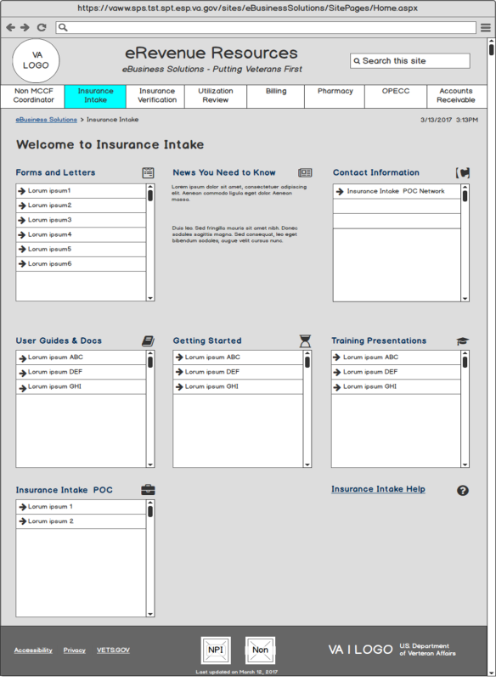

## 3.1.4 Insurance Verification Page

**Name:** Insurance Verification Page

**Type:** Web Page

**Description:** Clicking the **Insurance Verification** link from the **eRevenue Resource Home Page**, will display the **Insurance Verification Page** (as shown in Figure 4). This page will have a combination of web parts and links as shown in the following list:

* Header
* VALogo
* Page Title
* Search Bar
* Breadcrumb
* Current Date/Time
* Navigation Bar
* Home Page Icon
* Non MCCF Coordinator
* Insurance Intake
* Insurance Verification
* Utilization Review
* Billing
* Pharmacy
* OPECC
* Accounts Receivable
* **Web Parts (Accordions)**
* Job Aids
* References
* Contact Information – eInsurance
* Reports
* Training
* Laws, Regulations, Directives and Handbooks
* User Guides – eInsurance
* Resources
* Forms
* OIT Job Aids
* Insurance Verification POCs
* Insurance Intake POCs
* **Footer**
* Office of Community Care (OCC) Link
* Consolidated Patient Account Centers (CPAC) Link
* National Service Desk Link
* VA Pulse Link
* NPI Program Link
* Non-MCCF Program Link
* Star Logo Graphic
* Operations
* Pre-condition: Connected to site
* Post-condition: Document/Links accessed or connect to another page
* Exceptions: None
* Flow of Events

1. End user is presented with the Insurance Verification Page
2. End user selects link and is taken to another page
3. End user selects a document is the document is open

**Additional SharePoint Configuration:**

* Create a new SharePoint page (.aspx) to the site.

**Additional Technical Details:**

* Content for Insurance Verification page needs to be applied – accordion controls, calendars, etc.

**Requirements Traceability:**

* US241 – Site Performance
* US243 – Back Button Functionality
* US244 – Hover Text Disappearing
* US248 – Search Icon Missing Next to Search Bar on eBusiness Solutions Home Page, Project and Profile Pages
* US249 – Update to Overall Search Functionality
* US253 – Search - Displaying Multiple Icons
* US254 – Calendar-News You Need to Know Announcement Background
* US256 – Unable to Open Documents or Links (Multiple Pages)
* US257 – Duplicate Document Display
* US259 – Site Generate Emails
* US261 – Document Prioritization Order
* US262 – Unable to View Newly Created Announcements
* US264 – Calendar-News You Need to Know- Shrinking Pages
* US270 – Migration from SharePoint 2010 to SharePoint 2013 (EO) - Beta Site
* US271 – Validate Site is 508 Compliant - Features/Changes Post Migration
* US275 – Complete Development in PROD
* US1385 – Blank IE Tab - Selecting Documents/Links
* US1386 – Spell Check
* US1387 – NPI Project Page
* US1392 – Global View More Feature
* US1681 – Develop Master Page – Sprint 1
* US1710 – UI Usability and Consistency Changes
* US1758 – Master Page Development – Sprint 2

Figure : Wireframe

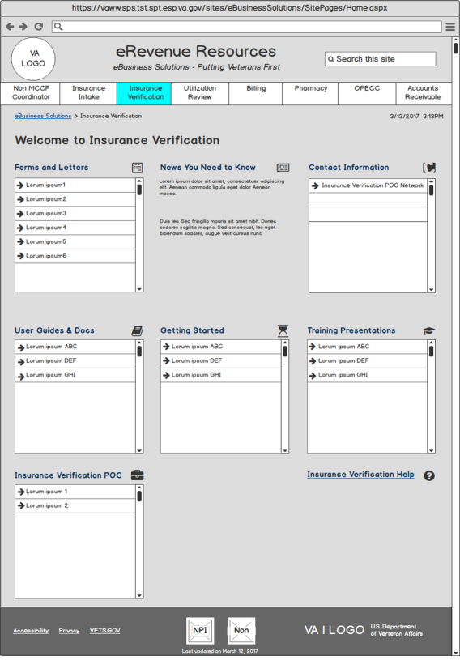

## 3.1.5 Utilization Review Page

**Name:** Utilization Review Page

**Type:** Web Page

**Description:** Clicking the **Utilization Review** link from the **eRevenue Resource Home Page**, will display the **Utilization Review Page** (as shown Figure 5). This page will have a combination of web parts and links as shown in the following list:

* Header
* VA Logo
* Page Title
* Search Bar
* Breadcrumb
* Current Date/Time
* Navigation Bar
* Home Page Icon
* Non MCCF Coordinator
* Insurance Intake
* Insurance Verification
* Utilization Review
* Billing
* Pharmacy
* OPECC
* Accounts Receivable
* Web Parts (Accordions)
* Training Presentations
* Updates
* Prior Authorizations – EDI
* Utilization Review Help
* **Footer**
* Office of Community Care (OCC) Link
* Consolidated Patient Account Centers (CPAC) Link
* National Service Desk Link
* VA Pulse Link
* NPI Program Link
* Non-MCCF Program Link
* Star Logo Graphic
* Operations
* Pre-condition: Connected to site
* Post-condition: Document/Links accessed or connect to another page
* Exceptions: None
* Flow of Events

1. End user is presented with the Utilization Review Page
2. End user selects link and is taken to another page
3. End user selects a document is the document is open

**Additional SharePoint Configuration:**

* Create a new SharePoint page (.aspx) to the site.

**Additional Technical Details:**

* Content for Utilization Review page needs to be applied – accordion controls, calendars, etc.

**Requirements Traceability:**

* US241 – Site Performance
* US243 – Back Button Functionality
* US244 – Hover Text Disappearing
* US248 – Search Icon Missing Next to Search Bar on eBusiness Solutions Home Page, Project and Profile Pages
* US249 – Update to Overall Search Functionality
* US253 – Search - Displaying Multiple Icons
* US254 – Calendar-News You Need to Know Announcement Background
* US256 – Unable to Open Documents or Links (Multiple Pages)
* US257 – Duplicate Document Display
* US259 – Site Generate Emails
* US261 – Document Prioritization Order
* US262 – Unable to View Newly Created Announcements
* US264 – Calendar-News You Need to Know- Shrinking Pages
* US270 – Migration from SharePoint 2010 to SharePoint 2013 (EO) - Beta Site
* US271 – Validate Site is 508 Compliant - Features/Changes Post Migration
* US275 – Complete Development in PROD
* US1385 – Blank IE Tab - Selecting Documents/Links
* US1386 – Spell Check
* US1387 – NPI Project Page
* US1392 – Global View More Feature
* US1681 – Develop Master Page – Sprint 1
* US1710 – UI Usability and Consistency Changes
* US1758 – Master Page Development – Sprint 2

Figure : Wireframe

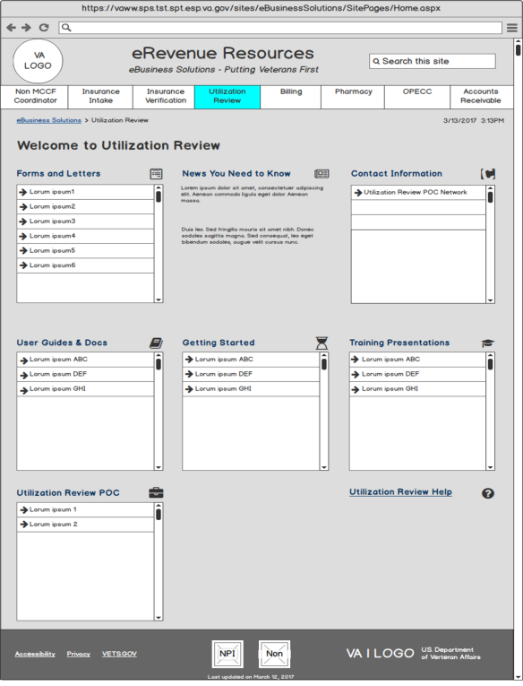

## 3.1.6 Billing

**Name:** Billing Page

**Type:** Web Page

**Description:** Clicking the **Billing** link from the **eRevenue Resource Home Page**, will display the **Billing** **Page** (see Figure 6, Figure 7, and Figure 8). This page will have a combination of web parts and links. This page will have a combination of web parts and links as shown in the following list:

* Header
* VA Logo
* Page Title
* Search Bar
* Breadcrumb
* Current Date/Time
* Navigation Bar
* Home Page Icon
* Non MCCF Coordinator
* Insurance Intake
* Insurance Verification
* Utilization Review
* Billing
* Pharmacy
* OPECC
* Accounts Receivable
* Web Parts (Accordions)
* eBilling How to…
* EBilling Day to Day Process
* eBilling Contact Information
* eBilling Troubleshooting and Research
* eBilling Getting Started
* eBilling Forms and Letters
* eBilling Reports
* eBilling Maintenance and Parameter Settings
* eBilling Documentation
* eBilling POCs
* eBilling Help
* **Footer**
* Office of Community Care (OCC) Link
* Consolidated Patient Account Centers (CPAC) Link
* National Service Desk Link
* VA Pulse Link
* NPI Program Link
* Non-MCCF Program Link
* Star Logo Graphic
* Operations
* Pre-condition: Connected to site
* Post-condition: Document/Links accessed or connect to another page
* Exceptions: None
* Flow of Events

1. End user is presented with the Billing Page
2. End user selects link and is taken to another page
3. The end user selects a document to open

**Additional SharePoint Configuration:**

* Create a new SharePoint page (.aspx) to the site.

**Additional Technical Details:**

* Content for the Billing page needs to be applied – accordion controls, calendars, etc.

**Requirements Traceability:**

* US241 – Site Performance
* US243 – Back Button Functionality
* US244 – Hover Text Disappearing
* US248 – Search Icon Missing Next to Search Bar on eBusiness Solutions Home Page, Project and Profile Pages
* US249 – Update to Overall Search Functionality
* US253 – Search - Displaying Multiple Icons
* US254 – Calendar-News You Need to Know Announcement Background
* US256 – Unable to Open Documents or Links (Multiple Pages)
* US257 – Duplicate Document Display
* US259 – Site Generate Emails
* US261 – Document Prioritization Order
* US262 – Unable to View Newly Created Announcements
* US264 – Calendar-News You Need to Know- Shrinking Pages
* US270 – Migration from SharePoint 2010 to SharePoint 2013 (EO) - Beta Site
* US271 – Validate Site is 508 Compliant - Features/Changes Post Migration
* US275 – Complete Development in PROD
* US1385 – Blank IE Tab - Selecting Documents/Links
* US1386 – Spell Check
* US1387 – NPI Project Page
* US1392 – Global View More Feature
* US1681 – Develop Master Page – Sprint 1
* US1710 – UI Usability and Consistency Changes
* US1758 – Master Page Development – Sprint 2

Figure : Wireframes: Billing Page, v. 1

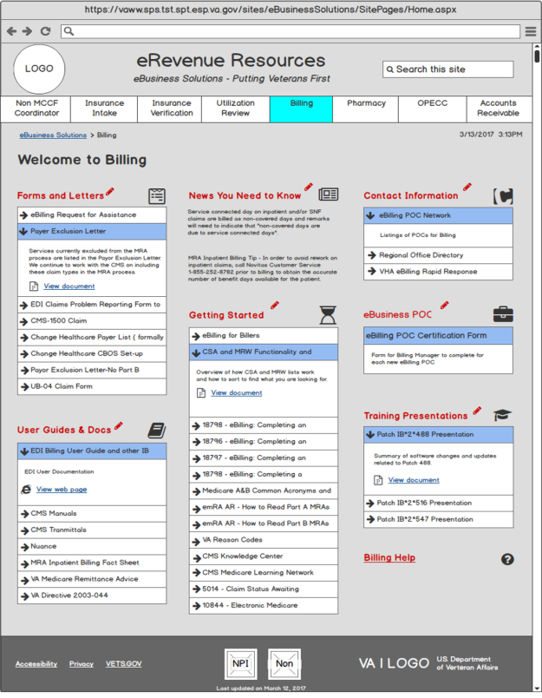

Figure : Billing Page, v. 2

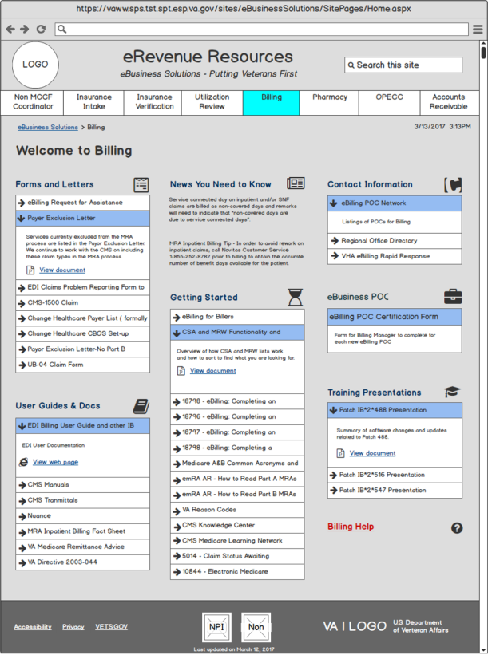

Figure : Billing Page, v. 3

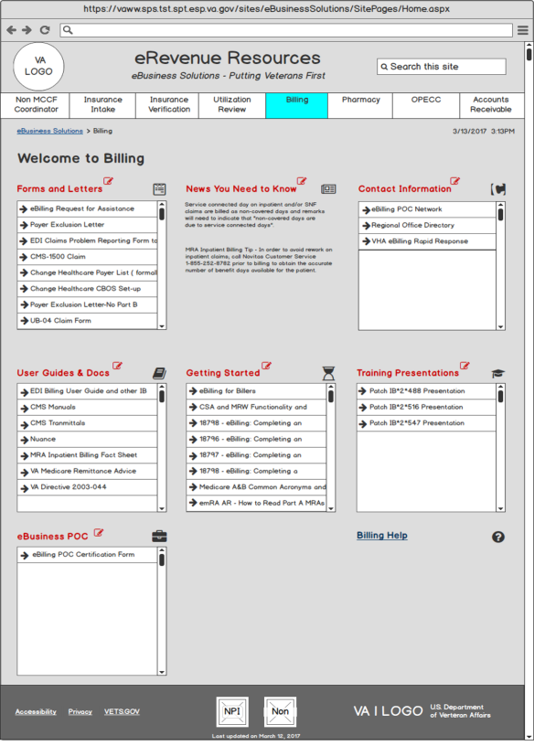

## 3.1.7 Pharmacy Page

**Name:** Pharmacy Page

**Type:** Web Page

**Description:** Clicking the **Pharmacy** link from the **eRevenue Resource Home Page**, will display the **Pharmacy Page** (as shown in Figure 9). This page will have a combination of web parts and links as shown in the following list:

* Header
* VA Logo
* Page Title
* Search Bar
* Breadcrumb
* Current Date/Time
* **Navigation Bar**
* Home Page Icoon
* Non MCCF Coordinator
* Insurance Intake
* Insurance Verification
* Utilization Review
* Billing
* Pharmacy
* OPECC
* Accounts Receivable
* Web Parts (Accordions)
* ePharmacy Site Manager
* Day to Day Resources
* ePharmacy Contact Information
* Training Presentations
* ePharmacy Forms
* User Guides and Documentation
* Footer
* Office of Community Care (OCC) Link
* Consolidated Patient Account Centers (CPAC) Link
* National Service Desk Link
* VA Pulse Link
* NPI Program Link
* Non-MCCF Program Link
* Star Logo Graphic
* Operations
* Pre-condition: Connected to site
* Post-condition: Document/Links accessed or connect to another page
* Exceptions: None
* Flow of Events

1. End user is presented with the Pharmacy Page
2. End user selects link and is taken to another page
3. The end user selects a document to open

**Additional SharePoint Configuration:**

* Create a new SharePoint page (.aspx) to the site.

**Additional Technical Details:**

* Content for Pharmacy page needs to be applied – accordion controls, calendars, etc.

**Requirements Traceability:**

* US241 – Site Performance
* US243 – Back Button Functionality
* US244 – Hover Text Disappearing
* US248 – Search Icon Missing Next to Search Bar on eBusiness Solutions Home Page, Project and Profile Pages
* US249 – Update to Overall Search Functionality
* US253 – Search - Displaying Multiple Icons
* US254 – Calendar-News You Need to Know Announcement Background
* US256 – Unable to Open Documents or Links (Multiple Pages)
* US257 – Duplicate Document Display
* US259 – Site Generate Emails
* US261 – Document Prioritization Order
* US262 – Unable to View Newly Created Announcements
* US264 – Calendar-News You Need to Know- Shrinking Pages
* US270 – Migration from SharePoint 2010 to SharePoint 2013 (EO) - Beta Site
* US271 – Validate Site is 508 Compliant - Features/Changes Post Migration
* US275 – Complete Development in PROD
* US1385 – Blank IE Tab - Selecting Documents/Links
* US1386 – Spell Check
* US1387 – NPI Project Page
* US1392 – Global View More Feature
* US1681 – Develop Master Page – Sprint 1
* US1710 – UI Usability and Consistency Changes
* US1758 – Master Page Development – Sprint 2

Figure : Wireframe

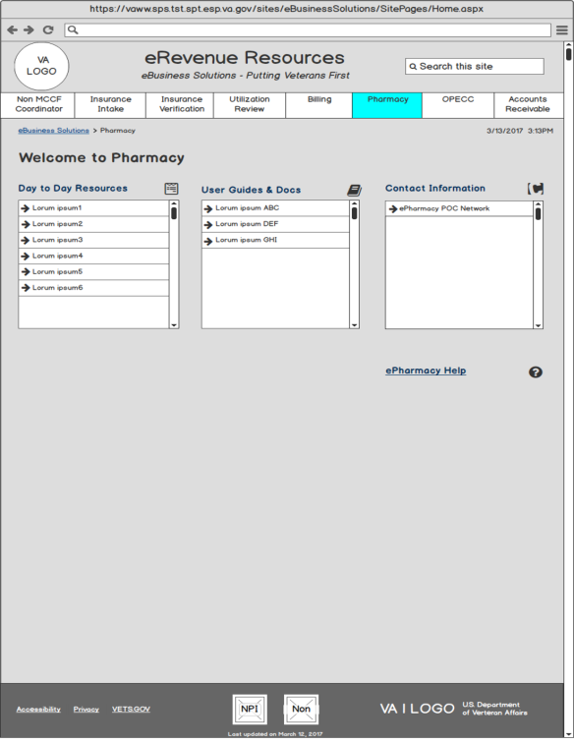

## 3.1.8 OPECC Page

**Name:**  OPECC Page

**Type:** Web Page

**Description:** Clicking the **OPECC** link from the eRevenue Resource Home Page, will display the OPECC page (as shown in Figure 10). This page will have a combination of web parts and links as shown in the following list:

* Header
* VA Logo
* Page Title
* Search Bar
* Breadcrumb
* Current Date/Time
* Navigation Bar
* Home Page Icon
* Non MCCF Coordinator
* Insurance Intake
* Insurance Verification
* Utilization Review
* Billing
* Pharmacy
* OPECC
* Accounts Receivable
* Web Parts (Accordions)
* Day to Day Resources
* Helpful Hints
* Contact Information
* ePharmacy Forms
* Training Presentations
* Getting Started
* User Documentation
* IRM Job Aids
* ePharmacy POCs
* Reference
* **Footer**
* Office of Community Care (OCC) Link
* Consolidated Patient Account Centers (CPAC) Link
* National Service Desk Link
* VA Pulse Link
* NPI Program Link
* Non-MCCF Program Link
* Star Logo Graphic
* Operations
* Pre-condition: Connected to site
* Post-condition: Document/Links accessed or connect to another page
* Exceptions: None
* Flow of Events

1. End user is presented with the OPECC Page
2. End user selects link and is taken to another page
3. End user selects a document and the document is open

**Additional SharePoint Configuration:**

* Create a new SharePoint page (.aspx) to the site.

**Additional Technical Details:**

* Content for OPECC page needs to be applied – accordion controls, calendars, etc.

**Requirements Traceability:**

* US241 – Site Performance
* US243 - Back Button Functionality
* US244 – Hover Text Disappearing
* US248 – Search Icon Missing Next to Search Bar on eBusiness Solutions Home Page, Project and Profile Pages
* US249 – Update to Overall Search Functionality
* US253 – Search - Displaying Multiple Icons
* US254 – Calendar-News You Need to Know Announcement Background
* US256 – Unable to Open Documents or Links (Multiple Pages)
* US257 – Duplicate Document Display
* US259 – Site Generate Emails
* US261 – Document Prioritization Order
* US262 – Unable to View Newly Created Announcements
* US264 – Calendar-News You Need to Know- Shrinking Pages
* US270 – Migration from SharePoint 2010 to SharePoint 2013 (EO) - Beta Site
* US271 – Validate Site is 508 Compliant - Features/Changes Post Migration
* US275 – Complete Development in PROD
* US1385 – Blank IE Tab - Selecting Documents/Links
* US1386 – Spell Check
* US1387 – NPI Project Page
* US1392 – Global View More Feature
* US1681 – Develop Master Page – Sprint 1
* US1710 – UI Usability and Consistency Changes
* US1758 – Master Page Development – Sprint 2

Figure : Wireframe

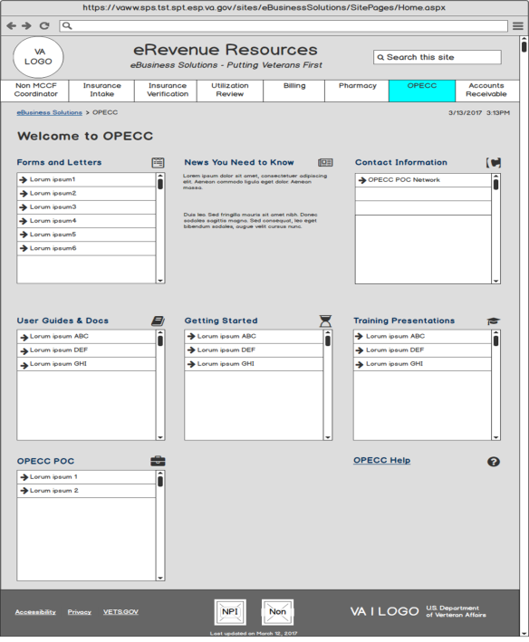

**3.1.9 Accounts Receivable Page**

**Name:** Accounts Receivable Page

**Type:** Web Page

**Description:** Clicking the Accounts Receivable link from the eRevenue Resource Home Page, will display the Accounts Receivable page (as shown in Figure 11). This page will have a combination of web parts and links as shown in the following list:

* Header
* VA Logo
* Page Title
* Search Bar
* Breadcrumb
* Current Date/Time
* Navigation Bar
* Home Page Icon
* Non MCCF Coordinator
* Insurance Intake
* Insurance Verification
* Utilization Review
* Billing
* Pharmacy
* OPECC
* Accounts Receivable
* Web Parts
* Day-to-Day Resources
* EPHRA
* Contact Information – ePayments
* ePayments Forms
* Training Presentations
* Scenarios and Exceptions
* Getting Started – ePayments
* ePayments Reports
* ePayments POC
* Footer
* Office of Community Care (OCC) Link
* Consolidated Patient Account Centers (CPAC) Link
* National Service Desk Link
* VA Pulse Link
* NPI Program Link
* Non-MCCF Program Link
* Star Logo Graphic
* Operations
* Pre-condition: Connected to site
* Post-condition: Document/Links accessed or connect to another page
* Exceptions: None
* Flow of Events:

1. End user is presented with the Accounts Receivable Page
2. End user selects link and is taken to another page
3. The end user selects a document to open

**Additional SharePoint Configuration:**

* Create a new SharePoint page (.aspx) to the site.

**Additional Technical Details:**

* Content for Accounts Receivable page needs to be applied – accordion controls, calendars, etc.

**Requirements Traceability:**

* US241 – Site Performance
* US243 – Back Button Functionality
* US244 – Hover Text Disappearing
* US248 – Search Icon Missing Next to Search Bar on eBusiness Solutions Home Page, Project and Profile Pages
* US249 – Update to Overall Search Functionality
* US253 – Search - Displaying Multiple Icons
* US254 – Calendar-News You Need to Know Announcement Background
* US256 – Unable to Open Documents or Links (Multiple Pages)
* US257 – Duplicate Document Display
* US259 – Site Generate Emails
* US261 – Document Prioritization Order
* US262 – Unable to View Newly Created Announcements
* US264 – Calendar-News You Need to Know- Shrinking Pages
* US270 – Migration from SharePoint 2010 to SharePoint 2013 (EO) - Beta Site
* US271 – Validate Site is 508 Compliant - Features/Changes Post Migration
* US275 – Complete Development in PROD
* US1385 – Blank IE Tab - Selecting Documents/Links
* US1386 – Spell Check
* US1387 – NPI Project Page
* US1392 – Global View More Feature
* US1681 – Develop Master Page – Sprint 1
* US1710 – UI Usability and Consistency Changes
* US1758 – Master Page Development – Sprint 2

**Figure 11: Wireframe**

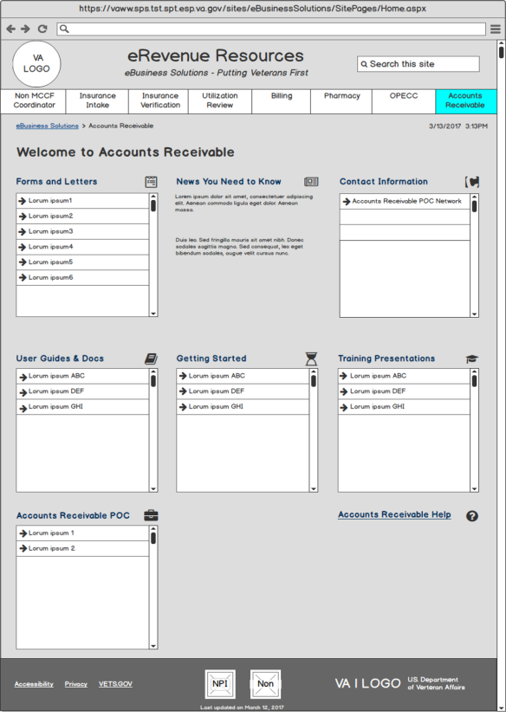

## 3.1.10 NPI Program Page

**Name:** NPI Program Page

**Type:** Web Page

**Description:** Clicking the NPI Program link from the eRevenue Resource Home Page, will display the NPI Program page. This page will have a combination of web parts and links as shown in the following list:

* Header
* VA Logo
* Page Title
* Search Bar
* Breadcrumb
* Current Date/Time
* Navigation Bar
* Home Page Icon
* Non MCCF Coordinator
* Insurance Intake
* Insurance Verification
* Utilization Review
* Billing
* Pharmacy
* OPECC
* Accounts Receivable
* Web Parts (Accordions)
* Legal Business Name Toolkit
* Practitioner Enrollment Toolkit
* Contact Information
* NPI Maintenance Team Leader
* NPI Resources
* Footer
* Office of Community Care (OCC) Link
* Consolidated Patient Account Centers (CPAC) Link
* National Service Desk Link
* VA Pulse Link
* NPI Program Link
* Non-MCCF Program Link
* Star Logo Graphic
* Operations
* Pre-condition: Connected to site
* Post-condition: Document/Links accessed or connect to another page
* Exceptions: None
* Flow of Events

1. End user is presented with the NPI Program Page
2. End user selects link and is taken to another page
3. The end user selects a document to open

**Additional SharePoint Configuration:**

* Create a new SharePoint page (.aspx) to the site.

**Additional Technical Details:**

* Content for Accounts Receivable page needs to be applied – accordion controls, calendars, etc.

**Requirements Traceability:**

* US241 – Site Performance
* US243 – Back Button Functionality
* US244 – Hover Text Disappearing
* US248 – Search Icon Missing Next to Search Bar on eBusiness Solutions Home Page, Project and Profile Pages
* US249 – Update to Overall Search Functionality
* US253 – Search - Displaying Multiple Icons
* US254 – Calendar-News You Need to Know Announcement Background
* US256 – Unable to Open Documents or Links (Multiple Pages)
* US257 – Duplicate Document Display
* US259 – Site Generate Emails
* US261 – Document Prioritization Order
* US262 – Unable to View Newly Created Announcements
* US264 – Calendar-News You Need to Know- Shrinking Pages
* US270 – Migration from SharePoint 2010 to SharePoint 2013 (EO) - Beta Site
* US271 – Validate Site is 508 Compliant - Features/Changes Post Migration
* US275 – Complete Development in PROD
* US1385 – Blank IE Tab - Selecting Documents/Links
* US1386 – Spell Check
* US1387 – NPI Project Page
* US1392 – Global View More Feature
* US1681 – Develop Master Page – Sprint 1
* US1710 – UI Usability and Consistency Changes
* US1758 – Master Page Development – Sprint 2

## 3.1.11 Non-MCCF Program Page

**Name:** Non-MCCF Program Page

**Type:** Web Page

**Description:** Clicking the **Non-MCCF Coordinator** link from the **eRevenue Resource Home Page**, will display the **Non MCCF Coordinator Page**. This page will have a combination of web parts and links as shown in the following list:

* Header
* VA Logo
* Page Title
* Search Bar
* Breadcrumb
* Current Date/Time
* Navigation Bar
* Home Page Icon
* Non MCCF Coordinator
* Insurance Intake
* Insurance Verification
* Utilization Review
* Billing
* Pharmacy
* OPECC
* Accounts Receivable
* Web Parts (Accordions)
* Contact Information
* Facility Insurance Verification
* Non-MCCF Billing Supervisor
* Biller – Non-MCCF
* Utilization Review – Non-MCCF
* OPECC – Non-MCCF
* AR Technician – Non-MCCF
* Non-MCCF POC Network
* Footer
* Office of Community Care (OCC) Link
* Consolidated Patient Account Centers (CPAC) Link
* National Service Desk Link
* VA Pulse Link
* NPI Program Link
* Non-MCCF Program Link
* Star Logo Graphic
* Operations
* Pre-condition: Connected to site
* Post-condition: Document/Links accessed or connect to another page
* Exceptions: None
* Flow of Events

1. End user is presented with the Accounts Receivable Page
2. End user selects link and is taken to another page
3. The end user selects a document to open

**Additional SharePoint Configuration:**

* Create a new SharePoint page (.aspx) to the site.

**Additional Technical Details:**

* Content for Accounts Receivable page needs to be applied – accordion controls, calendars, etc.

**Requirements Traceability**:

* US241 – Site Performance
* US243 – Back Button Functionality
* US244 – Hover Text Disappearing
* US248 – Search Icon Missing Next to Search Bar on eBusiness Solutions Home Page, Project and Profile Pages
* US249 – Update to Overall Search Functionality
* US253 – Search - Displaying Multiple Icons
* US254 – Calendar-News You Need to Know Announcement Background
* US256 – Unable to Open Documents or Links (Multiple Pages)
* US257 – Duplicate Document Display
* US259 – Site Generate Emails
* US261 – Document Prioritization Order
* US262 – Unable to View Newly Created Announcements
* US264 – Calendar-News You Need to Know- Shrinking Pages
* US270 – Migration from SharePoint 2010 to SharePoint 2013 (EO) - Beta Site
* US271 – Validate Site is 508 Compliant - Features/Changes Post Migration
* US275 – Complete Development in PROD
* US1385 – Blank IE Tab - Selecting Documents/Links
* US1386 – Spell Check
* US1387 – NPI Project Page
* US1392 – Global View More Feature
* US1681 – Develop Master Page – Sprint 1
* US1710 – UI Usability and Consistency Changes
* US1758 – Master Page Development – Sprint 2

### 3.1.12 Contact Information Window/Page

**Name:** Contact Information Page

**Type:** Pop Up Window

**Description:** Clicking on a link from the Contact Information web part from any page, will display the Contact Information email page (as shown in Figure 12) allowing the user to generate an email. The page contains:

* Header
* Defines what link was selected in the Contact Information web part
* **Drop Down Lists**
* Select a topic
* Select Station
* Text Boxes
* Subject

1. This will display the combined values selected from the drop down lists
2. Can be manually entered or edited
3. Field allows unlimited number of characters for input
4. Single line display

* Comments

1. User manually enters text
2. Field allows unlimited number of characters for input
3. Multiple lines displayed

* Operations
* Pre-condition: Connected to site
* Post-condition: The messages is emailed to the requested mail group
* Limitations:

1. For an email to be successfully sent the Subject and Comments fields must not exceed 255 characters.
2. If one or more fields exceed 255 characters an error message is displayed and the email is not sent.

* Exceptions: None
* Flow of Events:

1. End user is on the Contact Information email page
2. End user completes the required information
3. End user selects Submit
4. The server sends the message to the requested mail group and returns the end user to the page they were on previously
5. End user has the option to close the Contact Information email page which will clear the populated fields and not send the email
6. End user could also select Cancel at that time

**Additional SharePoint Configuration:**

* Created a BootStrap modal window.

**Additional Technical Details:**

* Called a BootStrap modal window, when called by the send e-mail button the page information is passed to the modal window, this information is used to select the topics for the page and populate the drop down list. Topics are unique from page to page. Station Id’s are the same from page to page.

**Requirements Traceability:**

* US241 – Site Performance
* US243 – Back Button Functionality
* US244 – Hover Text Disappearing
* US259 – Site Generate Emails
* US270 – Migration from SharePoint 2010 to SharePoint 2013 (EO) - Beta Site
* US271 – Validate Site is 508 Compliant - Features/Changes Post Migration
* US1385 – Blank IE Tab - Selecting Documents/Links
* US1386 – Spell Check
* US1710 – UI Usability and Consistency Changes
* US1765 – Nintex Workflow

Figure 12: Wireframe: US1392 – Global View More Feature

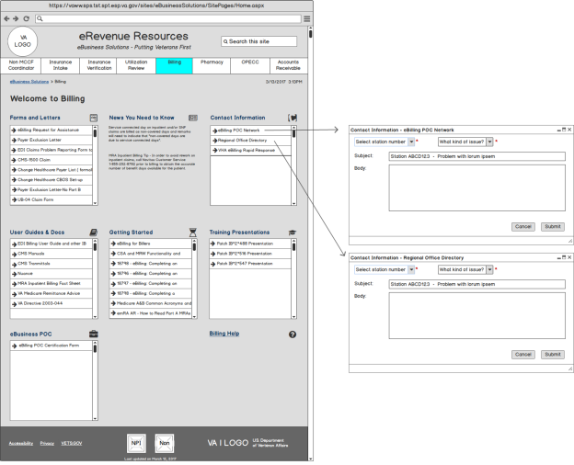

# How to Update Content

The purpose of this document is to allow SharePoint content owners to update content on the eRevenue Resources site. There are several features that can be used to add, update and delete content. The content can be organized in any way and offers flexible and easy way to manage documents. It is important for content owners to read this document to better understand the logic of managing eRevenue content.

# 4.1 SharePoint Objects

The following list defines the MCCF EDI SharePoint objects.

* eRevenuePage – A list containing the names of the eRevenue pages
* CBODocuments – A document library that stores files ( Word, Excel, PDF, Images, Links, PowerPoint)
* SectionApps – A list containing the headers of the accordions for each eRevenue page.
* eRevenue Images – An image library that stores the images used in the accordions
* Stations – A list containing all the station numbers and station names
* Help Documents – A document library storing “How To” Word documents for the site
* Calendar – A calendar where site content owners can add events that will be displayed under the calendar on the Home Page.
* Issues – A list containing issues that are used in a drop down menu in a modal window for contact information button
* Archive – A document library to store out dated documents that was once stored in CBO Documents.

The SharePoint objects can be found by clicking on the gear icon | Site Contents. Site content owners will need the appropriate permissions to be able to view these objects, otherwise they will not be able to access Site Contents. Permissions are granted by the Site Collection Administrator.

### CBODocuments

The site was developed using SharePoint 2013 as the backend technology. eRevenue pages are composed of accordion controls where panels can be expanded and collapsed. When a page loads, the accordion panel defaults to a collapsed state. Each panel represents a document that is stored inside a SharePoint document library called **CBODocuments*.*** Content owners will upload files to CBODocuments and apply metadata to these documents so they are displayed on the appropriate eRevenue page and within the correct accordion control.

**NOTE:** To navigate to CBODocuments, click on the **Gear Icon** | **Site Contents** | **CBODocuments**

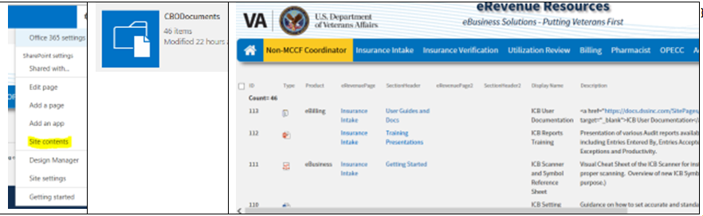

### 4.3 SectionApps

Each eRevenue page has a certain set of accordion controls. Controls can be easily managed through a SharePoint list called ***SectionApps.*** This list controls which accordions are displayed on each eRevenue page. The first column, ***SectionName*** contains metadata for accordion layout and must be listed using the word ‘Section’ followed by a number, ie Section1, Section2, Section3. See SectionApps list below. Each page may have a different number of accordions, starting with Section1 to Sectionx. Each page should have a minimum of three accordions – there is no maximum number but is advisable to keep this within reason.

### 4.1.5 eRevenue Page Layout

Each eRevenue page has the same layout. Each accordion is programmatically generated on each row represented by Section1, Section2 and Section3 and so on. On larger size screens, the page layout will display 3 accordions. If a user is viewing the site on a smaller screen such as an tablet or smartphone, the page will collapsed the controls so they are stacked on top on each other. This is applied via BootStrap 3.3.7 framework using JavaScript and CSS.

*SectionApps list eRevenue page layout by section number*

|  |  |
| --- | --- |
|  | Section1 Section2 Section3  Section4 Section5 Section6  Section7 Section8 Section9 |

**NOTE:** The numbers must always be in sequential order. **A number cannot be skipped. Section1 must always be the first name in the list.** There is no limit as to number of Sections that can be added to the list.

For example, if the list has Section1, Section3, Section4, Section5 -the page will display an error. However, if the list has Section1, Section5, Section2, Section3, Section4, this will work fine. The order of the Sections does not matter so long as numbers remain sequential.

The Title column represents the header title of the accordion. If an accordion title needs to be changed, edit the item row here. **See Section ‘How to edit accordion title.**

### 4.1.6 eRevenuePage and eRevenuePage2 Columns

There are two similar columns called eRevenuePage and eRevenuePage2 under the SectionApps list. They are located under the list setting of SectionApps. Each column is a SharePoint lookup that displays the title of another list called ***eRevenuePage***.

SectionApp Columns eRevenuePage Lookup eRevenuePage2 Lookup

|  |  |  |
| --- | --- | --- |
|  |  |  |

**4.1.7 eRevenuePage list**

This is a simple list with one column called Title. This column contains the name of the eRevenue page.

SectionApps Columns

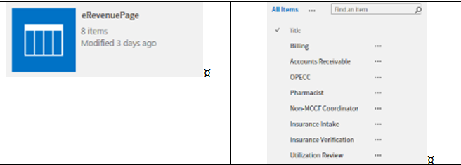

### 4.1.8 Add new eRevenue Page

Navigate to gear icon: Site Content | eRevenuePage |edit this list.

Click the last row of the list and enter a Page name under the Title column. This example is adding the NPI page

Click stop editing this list to save changes. New item will be displayed with a green asterisk.

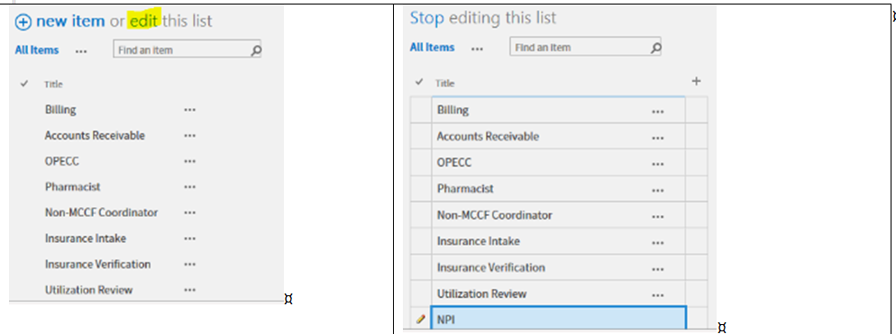

### 4.1.9 Add a New Accordion

Navigate to gear icon | Site Contents | SectionApps | edit this list.

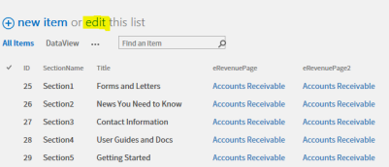

Scroll down to the bottom of the list and click the last row:

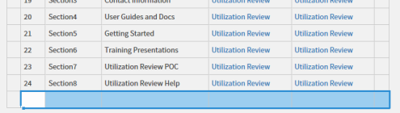

To add a new accordion, enter fields SectionName, and dropdowns for eRevenuePage and eRevenuePage2. **Remember, a new page must start with SectionName using ‘Section1’**. The accordion title is called ‘Forms and Letter’ and now NPIProgram will show up in the eRevenuePage dropdown and eRevenuePage2 dropdown.

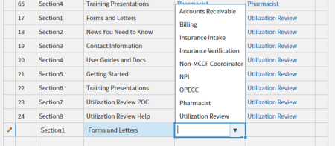

Scroll to the top of the list | Click stop editing this list to save changes. Newly added item should appear in the list which is sorted alphabetically by eRevenuePage column.

eRevenuePage Column

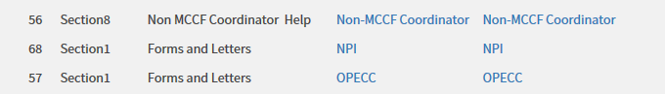

At this point, there is an NPIProgram page with one accordion called Forms and Letters.

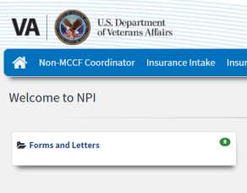

### 4.2.10 How to Upload a Document to Forms and Letters

Navigate to the gear icon | Site Contents | CBODocuments.

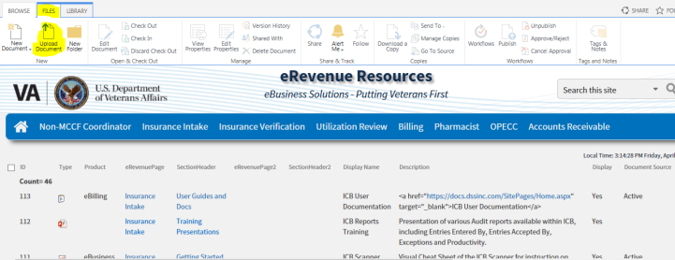

Section Files from the tab menu | Select upload document from the SharePoint ribbon ( see highlighted above).

A modal window with a file input control will appear. Click Browse and select the file.

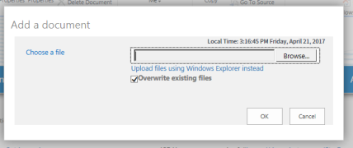

Another dialog window will appear requesting certain to be filled out:

|  |  |
| --- | --- |
|  | Product:  **eRevenuePage**: dynamic drop down list displaying all the pages from the ***eRevenuePage*** list.  **SectionHeader**: becomes dynamically populated when eRevenuePage option is selected.  The following 2 drop downs represent content owner being able to apply the same document on a secondary page.  **eRevenuePage2**: dynamic drop down list displaying all the pages from the ***eRevenuePage*** list.  **SectionHeader2**: becomes dynamically populated when eRevenuePage option is selected. **Display Name:** Name of document displayed in the accordion panel.  **Description**: text that displayed when the accordion panel is expanded.  **Document Format**: type of file ( Word, Excel, PPT)  **Display**: defaults to yes so the link will appear in the accordion. If set to no, link will not appear.  **Document Source**: defaults to active. If set to archive, a workflow will move the document to the Archive document library. Active documents remain in CBODocuments.  **OriginalDate:** date the document was uploaded.  Keywords: stored in the Term Store, content owners can use existing keywords or create new ones.  **Priority**: Sorts the documents in each accordion. |

|  |  |
| --- | --- |
|  | Product drop down: NPIProgram  eRevenuePage : NPIProgram  SectionHeader: Forms and Letters  eRevenuePage2: leave blank  SectionHeader2: leave blank  Display Name: enter any text  Description: enter any text  Document Format: Word  Display: Yes |

Click CheckIn button to save all metadata changes to the document.

Go to the NPI Program page and refresh the page to see the changes applied in CBODocuments.

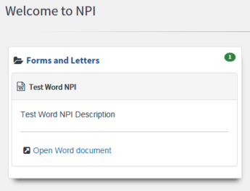

### 4.2.1 How to Hide a Link in the Accordion

If a document has already been uploaded but the link and description text need to be hidden, set the Display to No. Navigate to the gear | Site Contents | CBODocuments | Data view

In the CBODocument data view, select the file you modify and then click Edit Properties in the SharePoint ribbon.

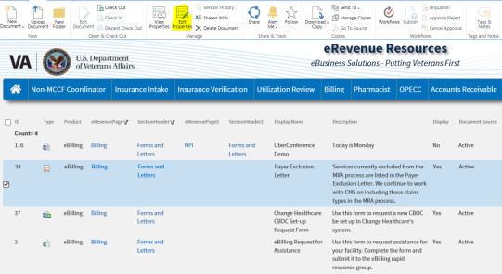

Change the display radio button from Yes to No and click Save.

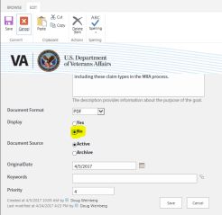

The data view reflects the changes applied in the Display column.

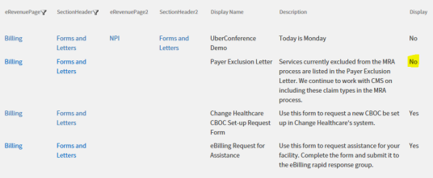

Refresh the Billing page and confirm that Forms and Letters accordion is NOT displaying Payer Exclusion Letter link.

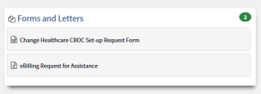

**4.2.2 How to Delete an Accordion**

Deleting an accordion is a simple process.

In this example, the News You Need to Know will be removed from Accounts Receivable page.

Go to the gear icon | Site contents | SectionApps list.

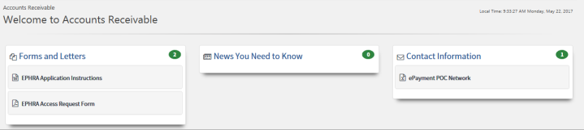

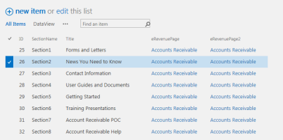

Select edit this list and select the News You Need to Know item.

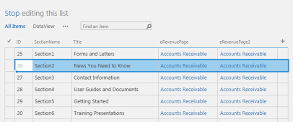

Go to the Items tab in the SharePoint ribbon and click delete.

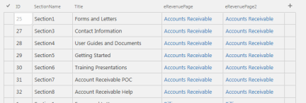

Section2 is now removed from the list. You must now rename the SectionName column and replace Section3 with Section2 and follow this patter until numbers are consecutive.

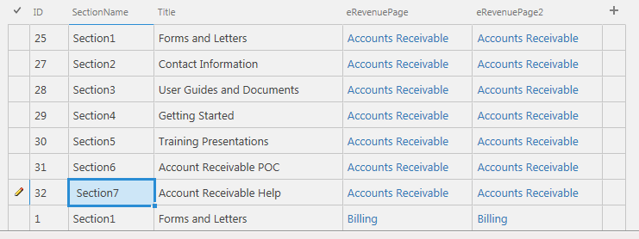

Click “Stop” editing this list to save your changes.

Confirm your changes by refreshing the Accounts Receivable page. News You Need to Know has been successfully deleted.

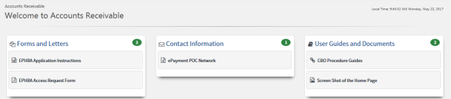  
  
**NOTE**: If you delete an accordion that has documents associated with it, the documents will not be deleted.

### 4.2.3 How to Upload Images and Hyperlinks to CBO Documents

|  |  |
| --- | --- |
| Go to the dashboard page: <https://vaww.vashare.vha.va.gov/sites/eRevenueResources/pages/dashboard.aspx>  1. Click Site contents link 2. Open ***eRevenue Images*** |  |
| 1. Click (+) new document 2. Browse for the image in dialog window |  |
| 1. Enter a title, description and keywords Title (not required) |  |
| 1. Click Save – image is now in the images library |  |
| 1. Click on the yellow highlighted area. 2. Click on the highlighted area again. |  |
| 1. Copy the URL   <https://vaww.vashare.vha.va.gov/sites/eRevenueResources/eRevenue%20Images/valogojpg.jpg> |  |
| 1. Create a new text file and paste in the URL. Update the text by adding the image source HTML markup: | **<img src="**https://vaww.vashare.vha.va.gov/sites/eRevenueResources/eRevenue%20Images/valogojpg.jpg" **width=275px"|** |
| 1. Copy all the code, save the text file and go back to CBODocuments library. 2. Go to files tab and click upload document, upload the text file. |  |
| 1. Fill out the required fields and make sure to paste the markup from the text file in the description field – see highlight. Select “None” for document source. |  |
| 1. Click “Save CBO Content” button.   The document has been added and the list updated: |  |

**Final Result:**

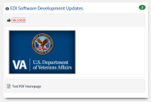

* + 1. **How to Upload Hyperlinks to CBO Documents**

1. Create a new text file and enter the markup. Replace the bold italic text with the link you want to add.

<a href="http://vaww.va.gov/cbo/" target="_blank" |Office of Community Care</a|

1. Paste the markup in a text file and save; be sure to also copy the markup.
2. Go to CBODocuments and upload the text file.|
3. Enter the required fields and paste the markup in the description field. Make sure you select “Link” as the Document Format. Save changes.

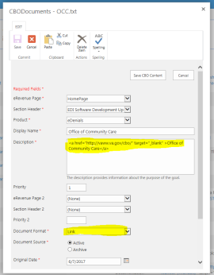

5. Confirm list has been updated with the correct meta-data.



6. Go the page to see the result. Click the link and it will open in a new IE tab.

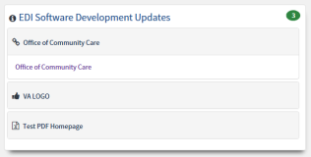

* + 1. **How to Create a HELP Link**

The dashboard page contains a list of all the Wiki Help pages. Go to the dashboard page using the following link: <https://vaww.vashare.vha.va.gov/sites/eRevenueResources/Pages/dashboard.aspx>

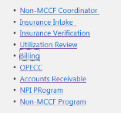

Each link in the above image has a Wiki Help Page. Click on a product/page link to visit the help page of that product.

This example will demonstrate how to set up a Help Link to the Billing Wiki Page: <https://vaww.vashare.vha.va.gov/sites/eRevenueResources/help/Pages/Billing.aspx>

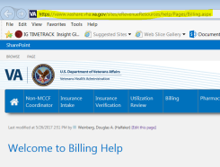

1. Copy the URL – highlighted yellow field in the browser window.
2. Go to SectionApps list to create the Help accordion.
   1. <https://vaww.vashare.vha.va.gov/sites/eRevenueResources/Lists/SectionApps/AllItems.aspx>
   2. Filter the list with Billing
   3. Click Edit this list:
   4. Update the list as shown below. Billing Help with Section 11 was added to the list.  
      Click Stop editing this list to save your changes.

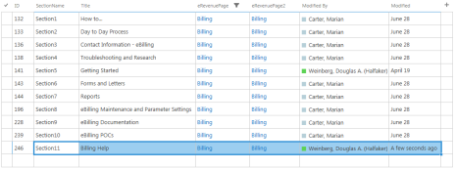

1. Go to the Billing page to confirm empty accordion was added.



1. To add a link, open NotePad and paste in the following:

|  |  |
| --- | --- |
| <a href="https://vaww.vashare.vha.va.gov/sites/eRevenueResources/help/Pages/Billing.aspx" target="_blank" |Billing Help</a| |  |

|  |  |
| --- | --- |
| 1. Save the file and then upload it to CBODocuments similar to step 4.6 2. Go to CBODocuments and upload the text file.| 3. Enter the required fields and paste the markup in the description field. Make sure you select “Link” as the Document Format. Save changes. |  |
| 1. Confirm the link is appearing in the accordion |  |

**Requirements Traceability:**

* US241 – Site Performance
* US243 – Back Button Functionality
* US254 – Calendar-News You Need to Know Announcement Background
* US255 – Calendar - Foreign Object Display
* US256 – Unable to Open Documents or Links (Multiple Pages)
* US257 – Duplicate Document Display
* US261 – Document Prioritization Order
* US262 – Unable to View Newly Created Announcements
* US264 – Calendar-News You Need to Know- Shrinking Pages
* US270 – Migration from SharePoint 2010 to SharePoint 2013 (EO) - Beta Site
* US271 – Validate Site is 508 Compliant - Features/Changes Post Migration
* US1386 – Spell Check
* US1387 – NPI Project Page
* US1681 – Develop Master Page – Sprint 1
* US1758 – Master Page Development – Sprint 2

Additional SharePoint Configuration:

Does not apply

**Additional Technical Details:**

None

# 5.0 Nintex Workflow

The Nintex workflow is designed to move documents between two document libraries: CBODocuments and Archive under the eRevenue SharePoint site. The workflow will move all the meta-data between these libraries.

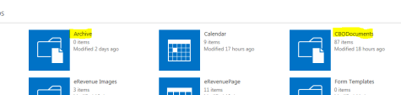

# 5.1 How to Archive a Document

This section will explain how documents get archived.

|  |  |
| --- | --- |
| * Decide which document needs to be archived.  In this example, the Helpful Hints – November 2014 will be archived. This document is located under the Day to Day Resources accordion. |  |
| * Go to the dashboard page: <https://vaww.vashare.vha.va.gov/sites/eRevenueResources/pages/dashboard.aspx> * Click All Docs View link: <https://vaww.vashare.vha.va.gov/sites/eRevenueResources/CBODocuments/Forms/AllItems.aspx> |  |
| The current state of the Document Source is set to “Active” | |
| * To archive, highlight the document | Files tab | Edit Properties |  |
| * Change the radio selection under Document Source to Archive * Click Save CBO Content button |  |
| * A Nintex workflow will move the file from the CBODocument library to the Archive library. * To confirm the document has been successfully moved open the Archive document library at the following link:   <https://vaww.vashare.vha.va.gov/sites/eRevenueResources/Archive/Forms/AllItems.aspx> |  |
|  | |
| Go back to the page where the document was once viewable and confirm the document is no longer visible in the accordion. |  |

# 5.2 How Move Documents Back to CBO Documents

The Nintex workflow is also designed to move documents back to CBODocuments. Use the same process as before.

|  |  |
| --- | --- |
| Go to the dashboard page and select the Archive link:  <https://vaww.vashare.vha.va.gov/sites/eRevenueResources/Archive/Forms/AllItems.aspx> |  |
| Highlight the document from the list | Files tab | Edit Properties |  |
| Change the Document Source drop down menu to Active | Click Save | Wait a few minutes |  |
| Once the workflow has completed, the highlighted document will no longer appear under the Archive list. You MUST hit refresh in the browser to confirm the change.  Document is no longer appearing in the list.  Go the CBODocuments: <https://vaww.vashare.vha.va.gov/sites/eRevenueResources/CBODocuments/Forms/AllItems.aspx> |  |
| The document is back in the list with a new ID value along with all the metadata. |  |
| The document is back in the Day to Day Resources accordion. |  |

Go back to CBODocuments and refresh page to confirm the document have been moved and all the metadata has copied over as well.

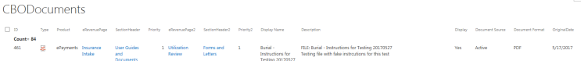

You will also notice the ID column has incremented one value – in this case 461. Notice Document Source is set to Active. Confirm the documents are being displayed on the correct eRevenue pages.

# 5.3 Using Dataview to Move Documents

**Note:** Using the data view, end users can change the Document Source from there as well.

<https://vaww.vashare.vha.va.gov/sites/eRevenueResources/CBODocuments/Forms/CBO%20Docs%20DataView.aspx>

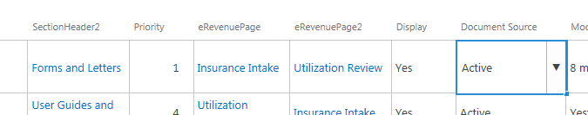

After the Active has been changed to Archive, click Stop to save data view changes to initiate Nintex workflow.

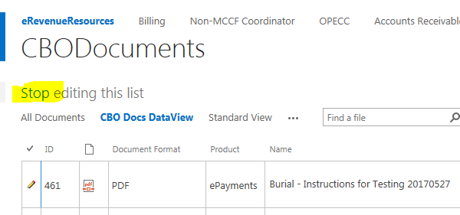

* Requirements Traceability:
* US249 – Update to Overall Search Functionality
* US257 – Duplicate Document Display
* US259 – Site Generate Emails
* US261 – Document Prioritization Order
* US1765 – Nintex Workflow
* US1681 – Develop Master Page – Sprint 1
* US1758 – Master Page Development – Sprint 2
* Additional SharePoint Configuration:
* Does not apply
* Additional Technical Details:
* None

# 6.0 Term Store or Keywords

To add a term or keyword to an existing document go to the gear icon | Site Contents | CBODocuments | select a document from the view | Files tab | Edit Properties button.

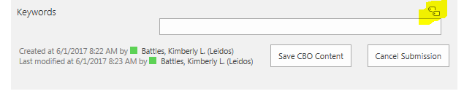

Click on the tag icon to open the Term Store. A Keywords dialog window will open up and display a tree view of the all associated terms used in the site.

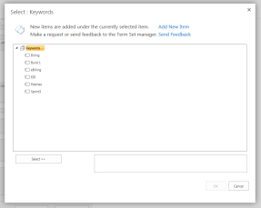

End user have 2 options: Use an existing term or create a new one.

# 6.1 Use an Existing Term

Click on the term in the tree view | Click Select | Click OK to save changes.

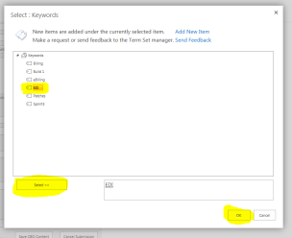

The existing term or keyword now appears in the keywords field.

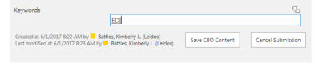

**6.2 Create a New Term**  
Click on the tag icon to open the Keywords Dialog window | Click the root of the tree – Keywords and then click ‘Add New Item’ link.

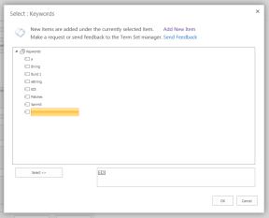

Type in the new keyword and then click Select to add it to the Keywords field.

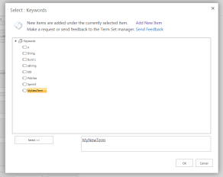

**Requirements Traceability:**

* US241 – Site Performance
* US270 – Migration from SharePoint 2010 to SharePoint 2013 (EO) - Beta Site
* US271 – Validate Site is 508 Compliant - Features/Changes Post Migration
* US275 – Complete Development in PROD
* US243 – Back Button Functionality
* US244 – Hover Text Disappearing
* US1385 – Blank IE Tab - Selecting Documents/Links
* Additional SharePoint Configuration:
* Does not apply
* Additional Technical Details:
* None

**7.0 Contact Email Form**

# 7.1 Business Requirements

A Contact Us section needs to be visible in a standard box on the page and must display the following:  
**eMail Link** Need the ability to email the Product Team from the associated Page Level 1 site (unique mailgroup for each page)

* The email address should be an active link and route to each teams email
* Based on the Product that each team is aligned with, this email would be available on each Page Level
* When the email is opened, the subject line should be unique so the Product Team can sort and track threads,
* The station number is required and available from pulldown list into the subject line
* Subject will include Page Level 1 title and selected station number

Go to any page and look for the Contact Information section. Click on the link ‘eBilling Rapid Response’ to expand accordion. Click on button ‘Send email’

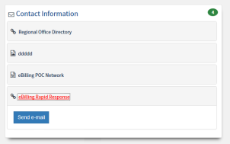

A modal window will appear. Users can select from 2 dropdown menues: topics and station. The topics dropdown is a dynamic menu option meaning the options under topic will change depending on the product that was selected. The stations dropdown menu reads data from a SharePoint list called Stations.

Stations list URL: <https://vaww.vashare.vha.va.gov/sites/eRevenueResources/Lists/Stations/AllItems.aspx>

End users can also type in a subject line as well.

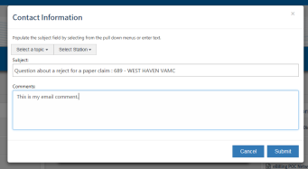

After entering text for the comments section, click ‘Submit’ and an alert box will appear letting user know an email was submitted.

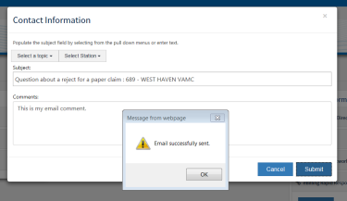

Click ‘OK’ and the modal window will be removed from the screen.   
Each email sent is logged to a SharePoint list called Contact Emails located in the *log* subsite. The contents of the email including the subject, product, body and the person that sent the email are stored in SharePoint list called “Contact emails” located at: <https://vaww.vashare.vha.va.gov/sites/eRevenueResources/log/Pages/default.aspx>

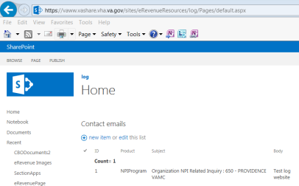

The email received contains the following content:

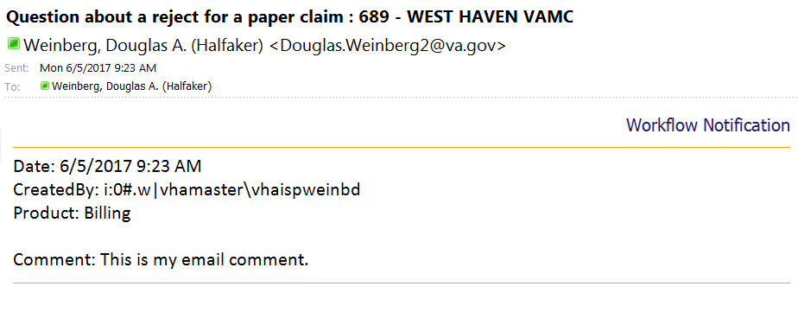

**7.2 Select a Topic Dropdown**

Select a topic drop dowm menu will dynamically display cetain issues that pertain to the Product Page. So Billing issues will have different options than Pharmacy. Each product page has its own subset of issues that are displayed for the Select a topic.

|  |  |  |
| --- | --- | --- |
| z  Non-MCCP Coordinator | Accounts Receivable | Insurance Verification |

All the options from the “Select a topic” dropdown are stored in a SharePoint list called “Issues” located at the following link:

<https://vaww.vashare.vha.va.gov/sites/eRevenueResources/Lists/Issues/AllItems.aspx>

This li**st** contains two columns: Product and Title ( title column is displayed in the dropdown menu).

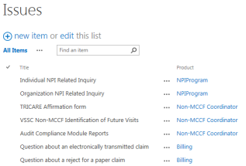

**7.3 Select Station Dropdown**

This dropdown pulls all the station numbers from a SharePoint list called Stations. Navigate to the Stations list:

<https://vaww.vashare.vha.va.gov/sites/eRevenueResources/Lists/Stations/AllItems.aspx>

Regardless of what product page the user is on, the list of station numbers remain the same for each page. There is no filtering or use of list item subsets. The dropdown will display all the stations numbers and station names from the Stations list.

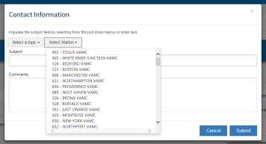

* Subject Line – Gets filled with option selected from Select a Topic concatenated with option from Select Station. This field can also have free text so user can enter any text without using dropdowns.

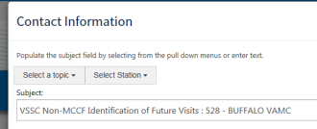

User enters text in the comments field and click “Submit” button to send the email. A dialog window will appear to let the user know email was successfully sent. When the user clicks “OK” the dialog window and the email button are removed from the screen.

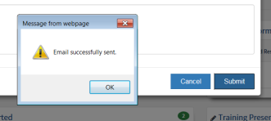

# 7.4 Sending the Email

The contents of the email are sent using Nintex Workflow called Send Contact Email.  
[https://vaww.vashare.vha.va.gov/sites/eRevenueResources/_layouts/15/NintexWorkflow/WorkflowGallery.aspx?ListId={ef6dc129-184f-4b68-b3e4-62b84294afdb}](https://vaww.vashare.vha.va.gov/sites/eRevenueResources/_layouts/15/NintexWorkflow/WorkflowGallery.aspx?ListId=%7bef6dc129-184f-4b68-b3e4-62b84294afdb%7d)

This workflow grabs the data from the Contact Email list and put each item in a workflow variable. The last action of the workflow is called ‘Send Notification’ which populates the variables in the subject line and body content of the email.  
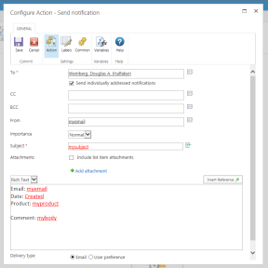

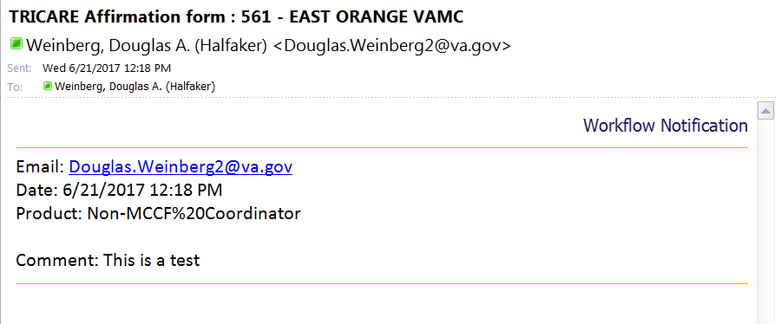

**Requirements Traceability**:

* US241 – Site Performance
* US243 – Back Button Functionality
* US244 – Hover Text Disappearing
* US259 – Site Generate Emails
* US270 – Migration from SharePoint 2010 to SharePoint 2013 (EO) - Beta Site
* US271 – Validate Site is 508 Compliant - Features/Changes Post Migration
* US1385 – Blank IE Tab - Selecting Documents/Links
* US1386 – Spell Check
* US1710 – UI Usability and Consistency Changes
* US1765 – Nintex Workflow
* Additional SharePoint Configuration:
* Does not apply
* Additional Technical Details:
* None